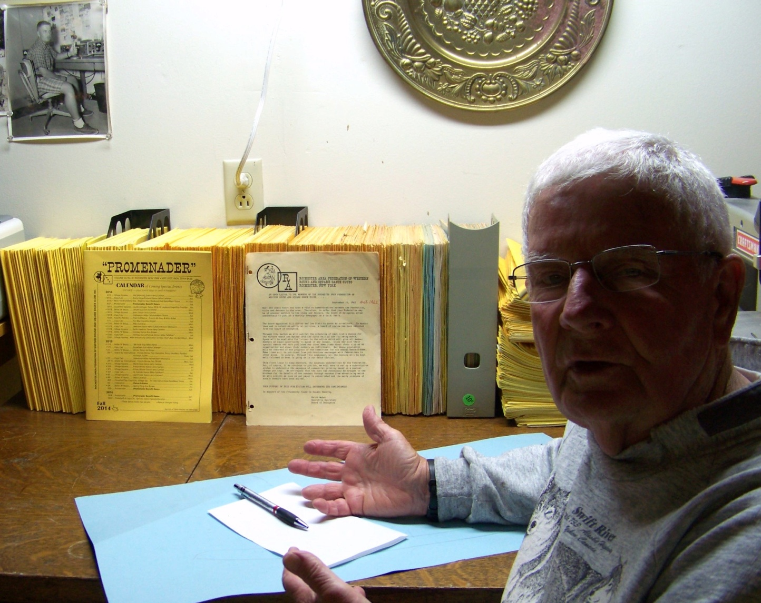
OVER A HALF CENTURY OF PUBLISHED PROMENADER ISSUES
Actually I had feared that a “Half Century of Promenader Issues”, a full set, plus extras, might extend wall-to-wall in my downstairs “2nd Office/Workshop!
The good news in terms of “manageability”, is that as you can see, they all fit nicely on my father’s old office desk that I now use as an overflow work area, and “Man Cave”!
Irma’s worst fears as expressed in her first reaction were:
“What are we going to do all of them?”
Alas! All has now been peacefully allayed. As you can see the full set, from the last published issue in 2014 on the extreme left in the picture, to the very first issue mailed out in October of 1962, covers just a little over three feet of desk space, and including the stack of “Extra Copies” stacked flat behind my right shoulder. The two black and one grey plastic containment open boxes add stability…needed especially for the early four-page plain paper stapled issues.
My plan is to devise a way, working with Sid and Peter, to copy these issues and make them “Historic Documents” under the HISTORY TAB in our website. These first two issues are very revealing in terms of how our Promenader came to be’ who was involved, and even the Promenader title itself. I envision just scanning them I; however, we will see how enlightening talks with Peter and Sidney resolve this.
My quick survey revealed that the first Editors were Lew Dietz and Bill Bibler, with Bill continuing until 1969, when Carl and Anita Warschkow took over these duties. On a personal note, Carl and I worked together at then RF Communications. I have not had time to discover any possible interim editors; however, I do know that Carl and Elaine Mallaber were for a number of years until Betty and Andy started their tenure with the September 1998 issue, and were still at the helm with our last printed issue ending in 2014.
One last observation before I end this for now, hoping to have piqued interest to the extent that we may soon have a small committee to work with me in recovering historically interesting information…such as, how many know the clubs that were active then: It is all in there, including club officers and a wealth of other information. The clubs then were: Belles N Beaus; Country Twirlers; EKC-O Squares; Fiddle A Rounds; Genesee Dancers; Irondequoit Squares; Swinging 8’s; and the Rochester Rolloways.
For anyone interested, we will happily offer access to these files at any time we are home. Heated in winter/Air-conditioned and humidity controlled year around…but Jan, Feb and March we are away for the winter!
Dick & Irma Halstead, Roving Reporters and Federation Historians
dickhalstead@gmail.com and tel. 315-926-5638

